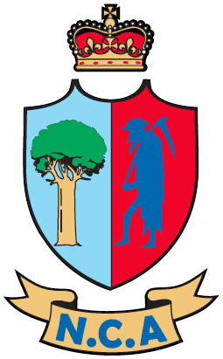

Position Title | Emerging Rangatahi Male Head Coach
Employer | District Association
Reports to | Pathway and Talent Coach - Northland
Term | 1 September 2022 to 15 April 2023 – Unpaid
Key Internal Relationships | Pathway Players, ND Team Operation Lead, ND Pathway and Talent Manager, District Association Board, District Association Coaches/Staff
Key External Relationships | NDCA Community Staff
Primary Objectives | Support the holistic development of our Rangatahi players across a seasonal calendar of activities

- Technical and Personal Competencies
  - Mandatory
- Strong relationship building skills that promote effective communication and high-level emotional intelligence towards all key stakeholders.
- Well-developed interpersonal skills with an ability to motivate, positively influence and build strong internal and external stakeholder relationships. Ability to create enjoyable learning environments.
- Cricket knowledge relating to the technical and tactical requirements of the game.
- Capable to work independently and as part of a team with the flexibility to interact with a wide range of staff/stakeholders including professional staff and volunteers.
- Full clean drivers’ licence.
  - Highly desirable
- Relevant Coaching Qualification - NZC Development or higher (or equivalent).
- Experience in community and/or professional sport.
- Demonstrated leadership skills with ability to build effective working relationships.
- Extensive knowledge of player development processes.

- Key Responsibilities and Accountabilities
- Lead all team/squad coaching responsibilities for the seasonal programme inclusive of regular training opportunities and attendance at tournament.
- Ensure provision of a safe and inclusive environment which encourages growth of players as both athletes and people in alignment with the ND philosophy of Pathways ‘Individual before performance’ as well as Sport NZ ‘Balance is Better’ principles.
- Lead discussions with players for key information such as playing roles etc.
- Assist in playing opportunity selections in alignment with selection criteria.
- Communicate summary reports for match and players to the Pathway and Talent Coach (if required).
- Ensure players and teams conduct themselves in an appropriate manner and represent the game in line with key values and expectations of the ‘Spirit of cricket’.

