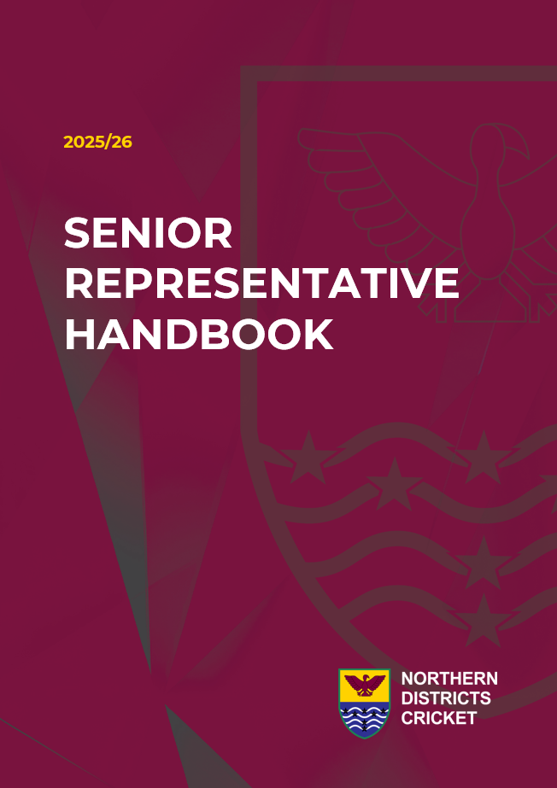

Contents
Contents 2
1 DIRECTORY 4

1.1 Definitions 4

1.1 ND Staff Leads 4
2 POSITIVE VIBES ONLY – OUR PHILISOPHIES 5
3 LAWS OF CRICKET 6
4 DRAWS 6

4.2 Fergus Hickey, Brian Dunning & Northern Brave Smash Draw 6

4.3 Women’s T20 & One day Draw 6
5 ALLOCATION OF UMPIRES AND MATCH OFFICIALS 6
6 MEN’S COMPETITION REGULATIONS 6

6.1 Competition Structure 6

6.2 Balls 6

6.3 Facilities/Services 7

6.4 Covers 7

6.5 Nomination of Players 7

6.6 Conduct of Players 7

6.7 Defaults 7

6.8 Clothing 7

6.9 Bowling Restrictions 8

6.10 Points 8

6.11 Tiebreaker Rules 8
7 MEN’S PLAYING CONDITIONS 9

7.1 Fergus Hickey Rosebowl 9

7.2 Brian Dunning Trophy 10

7.3 Northern Brave Smash 12

Men’s Super Smash Playing Conditions 12
8 Tournament Operations – NB T20 Smash 12

Sunday 14 December 12

Monday 15 December 12

Tuesday 16 December 12
9 WOMEN’S COMPETITION REGULATIONS 12

9.1 T20 Competition 12

9.2 One-Day Competition 13
10 WOMEN’S PLAYING CONDITIONS 13
11 SCORING 13

11.1 PlayHQ Player Registration 13

11.2 PlayHQ Scorecard Entry 13

11.3 Scoring and Scoreboard 13
12 REPORTING AND REPORTS 13

12.1 Captain Reports 13
13 HELMET POLICY 14
14 Health & Safety Plan 15

Contents 15
1. Event Information Centre 16
2. Site Map 16
3. Bathrooms 16
4. Parking 16
5. Emergency Procedures 16
6. General 16
7. Emergency Evacuation 16
8. Emergency Services 17
9. First Aid 17
10. Fire 17
11. Helmets 17
12. Incident 17
13. Site Hazards 17
14. Manual Handling 18
15. Appendices: 18

14.2 Appendix 1 – Owen Delany Park, Taupo 19

14.3 Appendix 2 – Hazard and Rish Assessment Form 20

14.4 Appendix 3 – Health & Safety Reporting 23

14.5 Appendix 3 – Helmet Policy 24

14.6 Appendix 4 – Concussion Management 25

14.7 Appendix 5 - Code of Conduct 27

DIRECTORY

1.1 Definitions
District Association (DA’s) | Northland Cricket Association (NCA)  Counties Manukau Cricket Association (CMCA)  Hamilton cricket Association (HCA)  Waikato Valley Cricket Association (WVCA)  Bay of Plenty Cricket Association (BOP)  Poverty Bay Cricket Association (PBCA)
ND | Northern Districts Cricket Association
The Region | The District Association competition relevant to the region for which the players club is affiliated
Competition Administration (CA) | Designated officials responsible for competitions operation and delivery.
The Board | Board of the DA or organising body from which the competition is affiliated, inclusive of any Sub Association and/or sub-committee

ND Staff Leads
Role | Name | Phone | Email
Competitions, Tournaments Lead | Collette Amai | 027 222 7893 | collette@ndca.co.nz
Competitions & Tournaments | Collette Amai | 027 222 7893 | competitions@ndca.co.nz
Regional Officials Coordinator and Umpire Developer | Luan Kloppers | 021 112 2195 | luan@ndca.co.nz

POSITIVE VIBES ONLY – OUR PHILISOPHIES
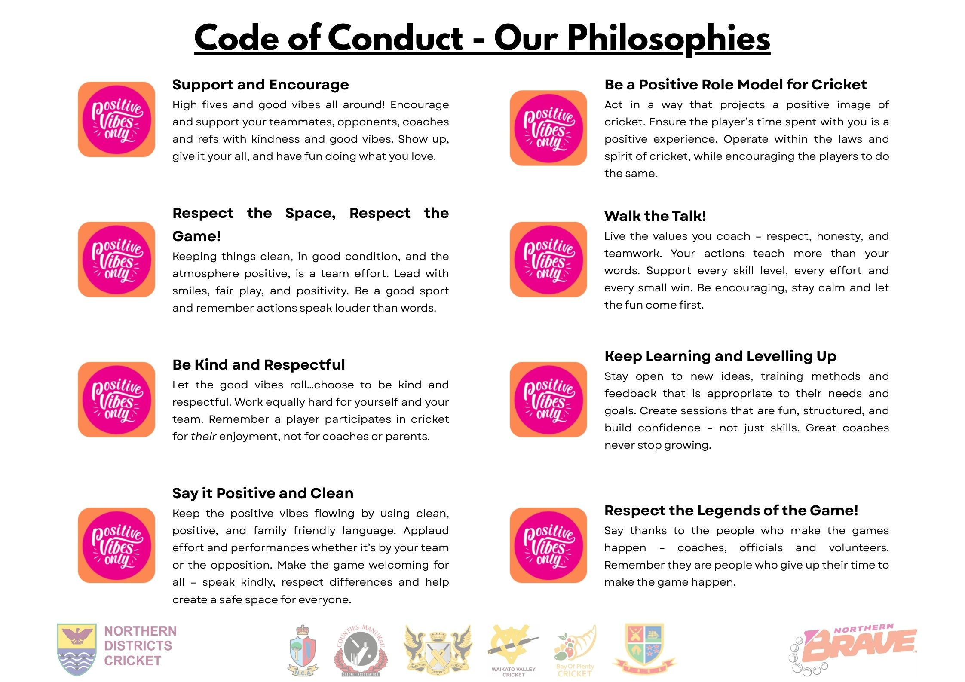

LAWS OF CRICKET
All laws of cricket are available to be viewed at the MCC Laws of Cricket website.

All competition matches shall be played subject to and in accordance with the Laws of Cricket and subject to the playing conditions adopted by New Zealand Cricket, subject to such amendments and modifications as ND may determine from time to time.

The Laws of Cricket 2017 Code (Second edition 2019)

DRAWS
The draw for the competition(s) and tournaments shall be completed by ND and once confirmed and notified to competing Associations there shall be no replays.

If a match date and/or venue is changed once the draw is published, please confirm this change with ND and opposition.

Fergus Hickey, Brian Dunning & Northern Brave Smash Draw
All draws for competitions and tournaments can be accessed here.

Women’s T20 & One day Draw
All draws for competitions and tournaments can be accessed here.

ALLOCATION OF UMPIRES AND MATCH OFFICIALS
Umpires will be allocated to games by Northern Districts Regional Officials Coordinator and Umpire Developer. Scorers will be provided by each association team.

MEN’S COMPETITION REGULATIONS

Competition Structure
Fergus Hickey Rosebowl: Teams will play a round robin series of two-day games.

Brian Dunning: Teams will play a round robin series of 50 overs games.

Northern Brave Smash: Teams will play a round robin series of T20 games.

Hawke Cup Elimination Series
The top points scorer in the Fergus Hickey Rosebowl matches in the calendar year annually and the first two rounds of the current season shall be the ND challenger for the Hawke Cup in the current year.

Balls
- In all two-day matches the ball to be used shall be RED four-piece 156g Kookaburra Regulation balls. Each District Association is responsible for these.
- In all one day matches the ball to be used shall be WHITE four-piece 156g Kookaburra Regulations balls. Each District Association is responsible for these.
- In all T20 matches the ball to be used shall be WHITE four-piece 156g Kookaburra Regulation/Turf balls. These will be provided by ND.

Facilities/Services
The host Association will endeavour to provide first class pitches, good outfields, adequate boundary dimensions, scoreboards and suitable changing facilities as defined in the District Association Warrant of Fitness. The host association will meet the ground and facility charges and will provide lunches and suitable refreshments prior to commencement of play, at lunch, at afternoon tea and at drinks’ breaks during play for all umpires, players and associated team officials.

Covers
The host Association shall ensure that the pitch to be used in any competition match is kept adequately covered during the period preceding the match. The pitch must be entirely protected against rain up to the commencement of play and for the duration of the period of the match. It shall be wholly covered at the termination of the day’s play or providing the weather is fine, within a period of two hours thereafter. Such coverings shall remain in position until a time no earlier than 5.00 a.m. and no later than 7.00 a.m. the following morning when they shall be removed if the weather is fine.

Where no ground staff are available it shall be the responsibility of the batting side to cover the pitch during the day’s play. It is recommended that the covers also protect the bowlers’ run ups to a reasonable distance. At the end of the day’s play, it is a responsibility of the host team to assist the ground staff to cover the pitch.

Nomination of Players
Teams may be composed of 12 players, but only 11 may bat. To maximize player participation the non-batter may be a different player in each innings - but the non-batters must be nominated before the start of each innings. All 12 players can field and bowl, but only 11 players are to be on the field at any one time.
Note that NZC Playing Conditions on substitutes [how long a player must be on the field before ability to bowl and when an absent player is permitted to bat] will apply.
The expectation is that all 12 players field for a minimum of 15 overs per innings. A player not meeting this requirement shall not be able to bat.

Conduct of Players
The ND Code of Conduct will apply to all players and team members. Please see ND Senior Competition Regulations for process and further information.

Defaults
If any District Association defaults in a match the following shall apply:
- The team defaulting shall lose six points, and non-offending team shall be awarded maximum points gained in that round.
- No points shall be gained or forfeited if a default is brought about by bad weather, accident, or other circumstances beyond the reasonable control of the defaulting team. ND shall, if necessary, determine whether the default has been so caused, and may re-schedule the match.

Clothing
All team uniforms must be approved by ND and worn by all team members:
- Representative teams must wear white clothing for all two-day fixtures.
- Representative teams must wear coloured clothing for all limited over fixtures.

Bowling Restrictions
The underage bowling restriction guidelines apply. These can be found on page 53 of the NZC Game On Resource, and are outlined below in the table.
Age | Bowling Restrictions | Sessions Per Week / Bowling Restriction
16 years | 14 Overs per Day  6 Overs per spell | 2 sessions per week  6 overs per session
17 years | 16 Overs per Day  6 Overs per spell | 2 sessions per week  6 overs per session
18 years | 20 Overs per Day  8 Overs per spell | 2 sessions per week  6 overs per session

Points

Fergus Hickey Rosebowl and Hawke Cup
Result | Points
Outright Win | 8
Outright Tie | 6
First innings Win | 4
First innings Tie | 2
First innings Draw (No First innings result achieved) | 2
Draw – Match abandoned or less than 50 overs possible | 4
If the team batting second has not faced 50 overs the game will be deemed a draw | 2
Batting Bonus Points | 1 at 200, 2 at 250, 3 at 300
Bowling Bonus Points | 1 at 3 wickets, 2 at 6 wickets, 3 at 9 wickets
* Bonus points up to 100 overs in the 1st innings [no compulsory declaration]
3 rounds to be completed to constitute a viable competition
If rounds cannot be completed due to extenuating circumstances, the team with the highest average points per round will be determined the winner

Brian Dunning Trophy & Northern Brave Smash
Result | Points
Win | 4
Abandoned or no result | 2
Loss | 0

Tiebreaker Rules

Fergus Hickey Rosebowl:
If points are tied for the Fergus Hickey Rosebowl, then the winner shall be determined as follows:
- The team which gains the most points in matches between the tied teams.
- If still no decision, the winner shall be determined by calculation of the runs per wicket between the teams which finish equal on points i.e. runs per wicket for minus runs per wicket against.

If points are tied to find the Hawke Cup challenger, then the team which gains the most points in games between the teams shall be awarded the challenge. If still no decision, then rule (b) above applies.

Note: if the holder of the Hawke Cup at the start of the season is a Northern Districts DA, this DA is not eligible to challenge should they lose the Hawke Cup prior to the ND challenge.

Brian Dunning & Northern Brave Smash
If points are tied after the completion of the round robin, then the winner shall be determined as follows:
- If two teams are on equal points, it will be determined via ‘Who beat who’ in the round robin.
- If there are three or more teams equal on points, then it will be decided on net run rate

MEN’S PLAYING CONDITIONS

Fergus Hickey Rosebowl
Plunket Shield Playing Conditions
Except hereunder NZC Playing Conditions for the Plunket Shield shall apply.

Hours of Play (Day 1 & 2)

Time | Session
10:30am – 12.50pm | Session 1
12:50pm – 1.30pm | Lunch
1.30pm – 3.40pm | Session 2
3:40pm – 4:00pm | Tea
4:00pm – 6:00pm | Session 3

On the second day by mutual agreement the captains may cease play one hour early provided there is no possibility of a result. Umpires may vary the length of the lunch/tea interval depending on conditions.

Minimum Overs
Play shall continue each day until the completion of a minimum number of overs (96) or until the scheduled cessation time, whichever is the later.
On Day 1, play shall not continue for more than 30 minutes beyond the scheduled or rescheduled close of play [permitted overtime]. Any overs not completed by the permitted overtime will be lost and cannot be made up on Day 2. The initial minimum number of overs to be completed on any day (unless there is an interruption to play) is 96. This is calculated at 15 overs per hour.
- The minimum number of overs per day shall be reduced by two for each break between innings. However, there is no reduction if the break between innings coincides with a lunch or tea interval.

Suspension of Play
If play is suspended, the minimum number of overs to be bowled in the day shall be calculated on whichever of the following two bases produces the greatest number of overs.

either
One over for each full 4minutes playing time remaining till the scheduled time for close of play (see NZC Playing Conditions 4 Day Over Rates calculation sheet)
or
The minimum number of overs agreed for the day, less the number of overs already bowled and less all allowances for suspension of play.

Last hour
On the last day 15 overs must be bowled in the last hour. The start of the last hour may be delayed so that it commences when 15 of the agreed minimum overs remain to be bowled.

Extension of Play
The hours may be extended on either day to make up for lost time in a day’s play because of light, weather, or any other unavoidable circumstances.
- Notwithstanding this, play must not be scheduled to go beyond 7:00pm on Day 1 nor 6.30pm on Day 2.
- When the hours of play per day are extended beyond the usual 6 ½ hours the minimum number of overs per day will increase by one over for every full 4 minutes of extra playing time (i.e. 15 overs per hour).
- The total number of scheduled hours must not exceed 13 hours.
- Lunch and tea intervals may be adjusted to suit the extended hours, with the agreement of the Umpires.
- Games may start up to 30 minutes early on the second day if more than one hour’s play is lost on Day 1.

Day One Abandoned: Change of format and/or pitch
If play is not possible on Day 1 then the match will proceed as a single innings game (not limited overs) on Day 2. The points for a first innings lead, tie, or draw will still apply.

If no play is possible on Day 1 and the ground or pitch is deemed by the Umpires to be unfit for play on Day 2, then the match will be abandoned. The game will not be transferred to artificial.

The Ball
- Per NZC 1st Class Playing Conditions. Except that Kookaburra Regulation balls should be used.
- The captain of the fielding side may request a new ball at the completion of 80 overs.

Declarations and Forfeiture – Law 14
It is not the intention that any declaration or forfeiture should become the subject of an agreement between captains. If the Umpires have grounds for thinking that such an agreement has taken place, they shall report accordingly to the ND Tournament Manager, and if ND is satisfied the agreement is proven, any points scored in that match shall be forfeited.
No team shall be allowed to declare its First Innings closed until at least one hour of playing time has elapsed since the start of that innings.

Brian Dunning Trophy
Except as modified hereunder the NZC Playing Conditions for the Ford Trophy shall apply.
Ford Trophy Playing Conditions

The Competition(s)
- Match will be 50 overs per side. A minimum of 20 overs will constitute a match.
- If weather prevents a game being played on a turf pitch, the game will not be transferred to artificial.

The Ball
- White Kookaburra Regulation 156g balls shall be used.

Nomination of Players:
- Teams may be composed of 12 players, but only 11 may bat.
- All 12 players can field and bowl, but only 11 players are to be on the field at any one time
- The 12th player may be rotated on and off the field, bearing in mind the rules of cricket in terms of eligibility to bowl in relation to a player’s time off the field (i.e if off the field for more than 8 minutes cannot bowl till back on for length of time off the field)

Hours of Play:
10.30am – 2pm | Session 1
2pm – 2.30pm | Interval
2.30pm – 6pm | Session 2
- Two drinks break per session shall be permitted, each one hour and 10 minutes apart.

Fielding Restrictions/Power Plays:
At the instant of delivery:
- Powerplay 1: no more than two (2) fielders shall be permitted outside this fielding restriction area. In an innings of 50 overs, these are overs 1 to 10 inclusive.
- Powerplay 2: no more than four (4) fielders shall be permitted outside this fielding restriction area. In an innings of 50 overs, these are overs 11 to 40 inclusive.
- Powerplay 3: no more than five (5) fielders shall be permitted outside this fielding restriction area. In an innings of 50 overs, these are overs 41 to 50 inclusive.

In circumstances when the number of overs of the batting team is reduced, the number of overs within each phase of the innings shall be reduced in accordance with the table below.

Innings duration | Powerplay 1 | Powerplay 2 | Powerplay 3 | Innings duration | Powerplay 1 | Powerplay 2 | Powerplay 3
20 | 4 | 12 | 4 | 35 | 7 | 21 | 7
21 | 4 | 13 | 4 | 36 | 7 | 22 | 7
22 | 5 | 13 | 4 | 37 | 8 | 22 | 7
23 | 5 | 14 | 4 | 38 | 8 | 23 | 7
24 | 5 | 14 | 5 | 39 | 8 | 23 | 8
25 | 5 | 15 | 5 | 40 | 8 | 24 | 8
26 | 5 | 16 | 5 | 41 | 8 | 25 | 8
27 | 6 | 16 | 5 | 42 | 9 | 25 | 8
28 | 6 | 17 | 5 | 43 | 9 | 26 | 8
29 | 6 | 17 | 6 | 44 | 9 | 26 | 9
30 | 6 | 18 | 6 | 45 | 9 | 27 | 9
31 | 6 | 19 | 6 | 46 | 9 | 28 | 9
32 | 7 | 19 | 6 | 47 | 10 | 28 | 9
33 | 7 | 20 | 6 | 48 | 10 | 29 | 9
34 | 7 | 20 | 7 | 49 | 10 | 29 | 10

Super Over
If teams are tied at the end of the game, a super over shall be played as described in NZC Ford Trophy Playing Conditions.

Northern Brave Smash
Except as modified hereunder the NZC Playing Conditions for Super Smash Cricket shall apply.

Men’s Super Smash Playing Conditions
Hours of Play
 | Morning Game | Afternoon Game
Session 1 | 10.30am – 11.55am | 2.30pm – 3.55pm
Interval | 11.55am – 12.15pm | 3.55pm – 4.15pm
Session 2 | 12.15pm – 1.40pm | 4.15pm – 5.40pm

A scheduled finishing time shall be set in case interruptions to play occur and calculations are required.
There are no overrate penalties, but captains and umpires are asked to monitor and maintain 4.25 minutes per over.

The Ball
White Kookaburra Regulation/Turf 156g balls shall be used.

Super Over
If teams are tied at the end of the game, a super over shall be played as described in NZC Super Smash Playing Conditions.

Tournament Operations – NB T20 Smash

Sunday 14 December
Time | Information | Location
12pm | Pre-tournament Umpires Meeting
12.30pm | Pre-tournament Coaches/Managers Meeting
1pm | Opening of Tournament & Team Photos
2.30pm | Game 1 – T20

Monday 15 December
Time | Information | Location
10.30am | Game 2 – T20
2.30pm | Game 3 – T20

Tuesday 16 December
Time | Information | Location
10.30am | Game 4 – T20
2.30pm | Game 5 – T20
6.30pm* | Close of Tournament (or as soon as games finish)

WOMEN’S COMPETITION REGULATIONS

T20 Competition
The Ball

One-Day Competition
The ball

WOMEN’S PLAYING CONDITIONS

SCORING

PlayHQ Player Registration
All players must be registered on PlayHQ and assigned to the correct teams.

PlayHQ Scorecard Entry
All games are to be scored on PlayHQ. District Associations are responsible for the entry of correct scorecards in PlayHQ. The scorecard for any game must be entered into PlayHQ by the District Association which is deemed to be the ‘home team’ (or the team on the left side of the draw). A full scorecard must be entered for a match which has a result or is abandoned.

In the event of PlayHQ technical issues, the team responsible to enter the scorecard must ensure that an email which explains the issue is communicated to ND before the deadline for results.

Scoring and Scoreboard
The home team is responsible for providing a scoreboard for each match. The batting team is responsible for updating scoreboards during the game.

REPORTING AND REPORTS

Captain Reports
Captains must complete an umpire report on this link for all matches and must be submitted by both team captains. The report deadlines are due to be completed by Tuesday 9am following completion of play and reports can be accessed online.

HELMET POLICY
District Association (DA) representative teams competing in ND tournaments and competitions:
The following policy will be mandatory. Helmets, with a face guard, are mandatory for all cricketers while playing and during practice sessions when batting, keeping (within 5 metres of the stumps) or fielding in close (within 7 metres of the stumps, excluding behind the wicket on the offside).

British Standard helmets (BS7928:2013) are considered “best of breed” helmets and supersede the old Australian/NZ Standard (AS/NZS 4499 series). For the amateur cricketer (Men and Women) who choose to wear a helmet, it is strongly recommended that the helmet meets the British Standard (BS7928:2013).

Any individual with responsibility for players (such as a coach or manager), together with match umpires, should take all reasonable steps to ensure that the above guidelines are followed.

Enforcement:
- Each DA must make the helmet policy available to all representative teams, team managers and coaching staff.
- Each DA should brief your team managers around the expectation that the helmet policy is tightly and closely enforced.
- Coaches and team managers should be aware that the match will be suspended until the player complies with the helmet policy.
- The helmets must be BS7928: 2013 compliant.

Helmet Replacement Policy:
    - A helmet must be replaced as follows:
    - After a severe impact from a cricket ball.
    - If you can see or feel any damage to any part of the head protector.
- After a hard knock causing indentation

Health & Safety Plan
NDCA will hold a number of events over the year. This plan relates to the event activities throughout the duration of the event:

- Setup prior to event
- Match day activities
- Pack up post event

This plan applies to the following:

- Event organisation staff
- Volunteers
- Participants
- Contractors
- Spectators

Contents

- Event Information Centre
- Site Map
- Bathrooms
- Parking
- Emergency Procedures
- General
- Emergency Evacuation
- Emergency Services
- First Aid
- Fire
- Helmets
- Incident
- Site Hazards
- Manual Handling
- Appendices

Event Information Centre
The designated Event Information Centre is to be based in the NDCA Tent; Refer Site Map. It will always be present during the event.
- This Event Office will also incorporate a gathering/collecting point for lost children
- All persons under the age of 18 should be accompanied by an adult.
- Whilst on site please follow the instruction of Event Organisers.

Site Map
- Please refer the Appendix 1. Site Map.
- Please observe the safety provisions exits, assembly point, toilets etc.
- Please observe which areas you may operate in, park etc.

Bathrooms
Bathrooms are located throughout the event as indicated in the site map
- Public toilets are located in the pavilion
- Signs are erected at the event to identify the toilet locations.

Parking
- Parking is available for event participants as identified on the site map
- Any persons parking illegally should be warned that their car may be ticketed/towed.

Emergency Procedures
All event staff, volunteers and contractors are to be provided with a copy of this plan and advised of the following emergency procedures.
- Staff, volunteers and contractors are to report any emergencies immediately to event management.
- Officials, Team Management and Coaching Staff are to report immediately to Tournament Organisers if they feel that their own safety or that of the public is in danger

General
If the verbal alarm is raised:
- Evacuate the area in an orderly fashion
- Event staff should assemble near pavilion
- Follow the instructions of Event organisers who shall provide instructions
- Re-enter after all clear is given by Tournament Organisers
- If you have an incident and require first aid Tournament Organisers must be notified immediately, and qualified first aiders must attend

Emergency Evacuation
In the event of an evacuation, Officials, Team Management and Coaching Staff are to:
  - Direct all activity participants and spectators to designated assembly point
  - Ensure their own safety if circumstances deteriorate
  - Assembly point area is located on the field and highlighted on site map.

Emergency Services
- Vehicle access for Emergency Vehicles is designated through the carpark
- A volunteer will be available with the key if required in emergency

First Aid
- St John will attend to all emergency situations requiring first aid (call 111)
- First Aid Kits are available.

Fire
- The event organiser is the designated Fire Warden and will coordinate emergency procedures should they occur.
- Evacuation assembly point is located on the site map.
- Officials, Team Management and Coaching Staff are to report any Fire emergency immediately to event headquarters
- Officials, Team Management and Coaching Staff should not attempt to put out fires if it will jeopardise their own safety.
- Firefighting equipment is not available at this venue

Helmets
The New Zealand Cricket Community Cricket Helmet Policy applies to all matches – see Appendix 2.

Incident
- In the event of a member of public sustaining a significant injury classed as a “Notifiable Event”, staff, volunteers and contractors are to:
  - Ensure their own safety first
  - Send someone to notify event organiser to request assistance from St John Ambulance
  - Assess the injury and only administer First Aid if you can do so and there is no additional exposure to risk.
  - Freeze the scene as much as possible.
  - Stay with the patient if it is possible to do so safely and
  - Try to keep patient calm.
  - Await instruction from First Aid staff or Event Management
  - Complete an incident form on EcoPortal with assistance from Event Organiser
  - Northern Districts Cricket are to notify WorkSafe for any Notifiable Events http://forms.worksafe.govt.nz/notifiable-event-notification
- Any player injuries shall be reported and recorded by their Team Manager or Coach.
- Report any near miss or incidents to the Team Manager or Coach.
- The Medical Plan attached will be required to be completed to identify any pre-existing medical conditions.
- Where a concussion injury has been identified, the Concussion Plan must be completed by the Event Organiser. Refer to Appendix. 4.

Site Hazards
- A pre-event hazard inspection will be undertaken, to identify physical hazards.
  - Identified site hazards are noted in the attached RAM form (Appendix 3).
  - Any construction site hazards will be noted specifically.
  - A Hazard register (RAM form or similar) will be on-site and completed accordingly and held at Event specified location.
- Note that site hazard register will only list identified hazards BEFORE event begins.
  - Any organisation conducting activities at the event must notify the Event organiser of any specific hazard associated with their operations.
  - Note that all individuals should also be on alert for other uncontrolled hazards they may encounter and report them to the Event Organiser
- Please read the Site Hazard Register (RAM form or similar) attached for a list of hazards on site. Please observe the controls and/or wear the Personal Protective Equipment (PPE) required and take steps to avoid these hazards.
- Any organisation conducting activities at the event must notify the Event Management of any specific hazard associated with their operations.

Manual Handling
- No person should lift more than they are capable of lifting. Get assistance if required.
- Always ensure the pathway is clear prior to moving anything.
For loads that can be carried by the individual:
- Stand as close to the load as possible with feet apart for good balance.
- Bend your knees to lift and lift directly upwards.
- Keep your back as straight as possible, keep your head up when lifting and carrying.
- Always keep the load as close as possible to your body, with elbows close to your sides making sure you can see where you are going.
- Do not twist your body to change direction, use your feet.

Appendices:
- Appendix 1. Site Map (Owen Delany Park)
- Appendix 2. RAM Hazard Register
- Appendix 3. Health & Safety Reporting
- Appendix 4. NZC Community Cricket Helmet Policy
- Appendix 5. Concussion Plan

Appendix 1 – Owen Delany Park, Taupo
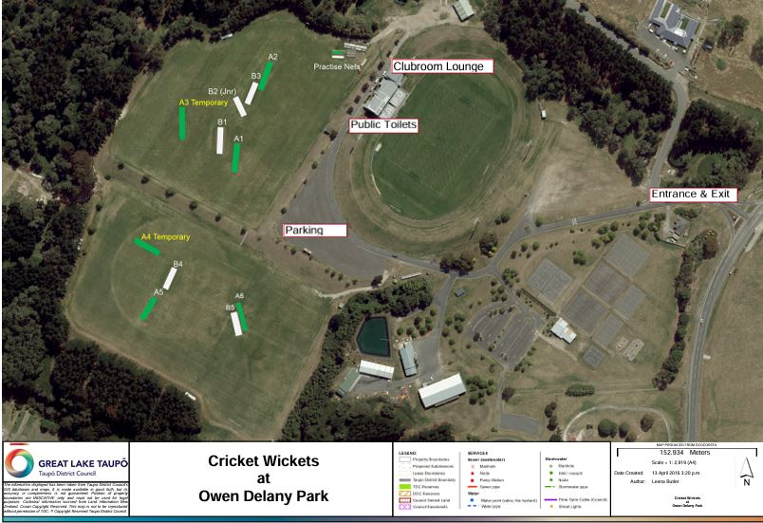

Appendix 2 – Hazard and Rish Assessment Form
For Programme Delivery and Event Management
Completed by: NDCA Operations or Event: Tournament Matches
Location: Owen Delany Park Date: 14 December – 16 December 2025
Hazard Identification  This process is to manage identified hazards & their associated risks that could negatively impact on worker health and safety  What can go wrong | Assessment of the Risk
 | Consequence/ Impact  - Fatality  - Permanent Disability  - Restricted Work  - Medical Treatment  - First Aid | Likelihood  Almost Certain  Likely  Possible  Unlikely  Highly Unlikely | Raw Risk Score  Extreme  High  Medium  Low | Controls – What would you do to reduce the impact  Eliminate, Substitute, Isolate, Engineering Controls, Administrative Controls, PPE | Residual Risk Score  Extreme  High  Medium  Low
Tsunami – Yellow Inundation area | A | Unlikely | Low | Must ensure all parties know the evacuation process and where to assemble | Low
Roller use – being struck | A | Unlikely | High | Must ensure area is clear of public when operating roller | Low
Outfield – holes, uneven surface | D | Possible | Medium | Clear of obstructions and all holes filled in | Low
Artificial pitches – proud exposed concrete | D | Possible | Medium | When concrete pitch meets the outfield, ensure ground level is equal to concrete pad | Low
Groundsman mowing - struck | A | Unlikely | High | When possible, have outfield mowing done prior to players arriving. If not possible, don’t allow warm ups on the field until mowing completed | Low
Erection of sightscreens – blowing over or out | D | Possible | Medium | 3 plus people to erect. The standards have to be driven into the correct depth. Ropes correctly fitted and tightened | Low
Steel pegs (standards) – impaled | A | Possible | Extreme | All standard pegs proud of the ground, must be covered in cushioning material | Medium
Tents blowing away- hitting people | A | Unlikely | High | Corners of all tents must be secured using correct length pegs | Low
Temporary fencing – people running into it | D | Likely | High | Keep back 2 metres from the boundary | Medium
Exposure to sun | D | Possible | Medium | RAMs form, rehydrate, sunscreen, protective clothing, signage, hats, scheduled safety meetings | Low
Sightscreen | B | Likely | Extreme | Scheduled maintenance, correct coloured equipment used. Scheduled safety meetings | High
Falling foliage from nearby trees | C | Likely | High | Housekeeping, pruning routines with local body, scheduled checks, scheduled safety meetings | Medium
Run-up maintenance | B | Unlikely | Moderate | Scheduled maintenance, scheduled checks, scheduled safety meetings | Low
Allergies – bee stings | A | Possible | Extreme | First aid kit, scheduled checks, scheduled safety meetings | High
Running | B | Possible | High | RAMs form, maintenance of surface, housekeeping, supervision, scheduled safety meetings | Medium
Throwing | B | Possible | High | RAMs form, equipment maintained, first aid training and kits available. Clear verbal instruction, supervision, scheduled safety meetings | Medium
Public passing through Park | E | Possible | Medium | Managers/coaches are security measures | Low
Striking activities | A | Possible | Extreme | RAMs form, equipment maintained, first aid training and kits available, clear verbal instruction, equipment maintained, supervision, scheduled safety meetings | High
Medical Incident | A | Possible | Extreme | RAMs form, equipment maintained, first aid training and kits available, clear verbal instruction, equipment maintained, supervision, scheduled safety meetings | High
Emergency evacuation | A | Almost certain | Extreme | Evacuation procedure/signage | Medium
Soft tissue injury | Restricted work | Likely | High | Dynamic warm up, awareness of physical restrictions, first aid qualified/kit, demonstration provided, | Medium
Hit by ball | Medical Treatment | Possible | Medium | Using tennis ball, demonstration, first aid qualified/kit, proper equipment, pace v competence, | Low
Hit by bat | Restricted work | Possible | Medium | Use plastic bat, demonstration, first aid qualified/kit, | Low
Slip/trip/fall | Fatality | Possible | Extreme | Suitable footwear, first aid qualified/kit, check surface, awareness, briefing, housekeeping, | High
Prior health condition | Fatality | Possible | Extreme | Awareness of restrictions, opt-out option, first aid qualified/kit | High
Collision | Medical Treatment | Possible | Medium | Situational awareness, first aid qualified/kit, demonstration, | Low
Equipment failure | Medical Treatment | Unlikely | Medium | Equipment well maintained and regularly checked first aid trained/kit | Low

Appendix 3 – Health & Safety Reporting



Appendix 3 – Helmet Policy
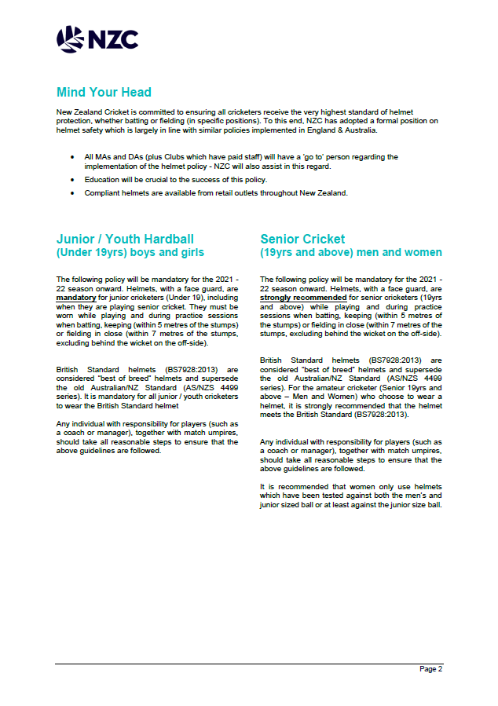


Appendix 4 – Concussion Management

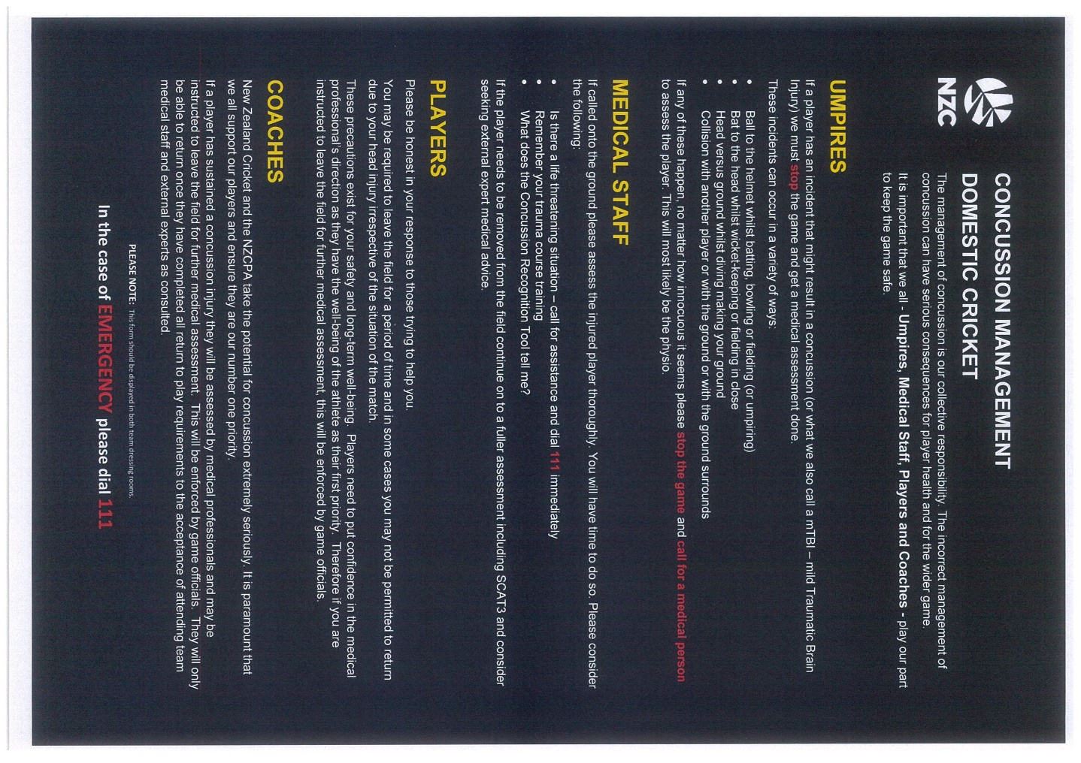

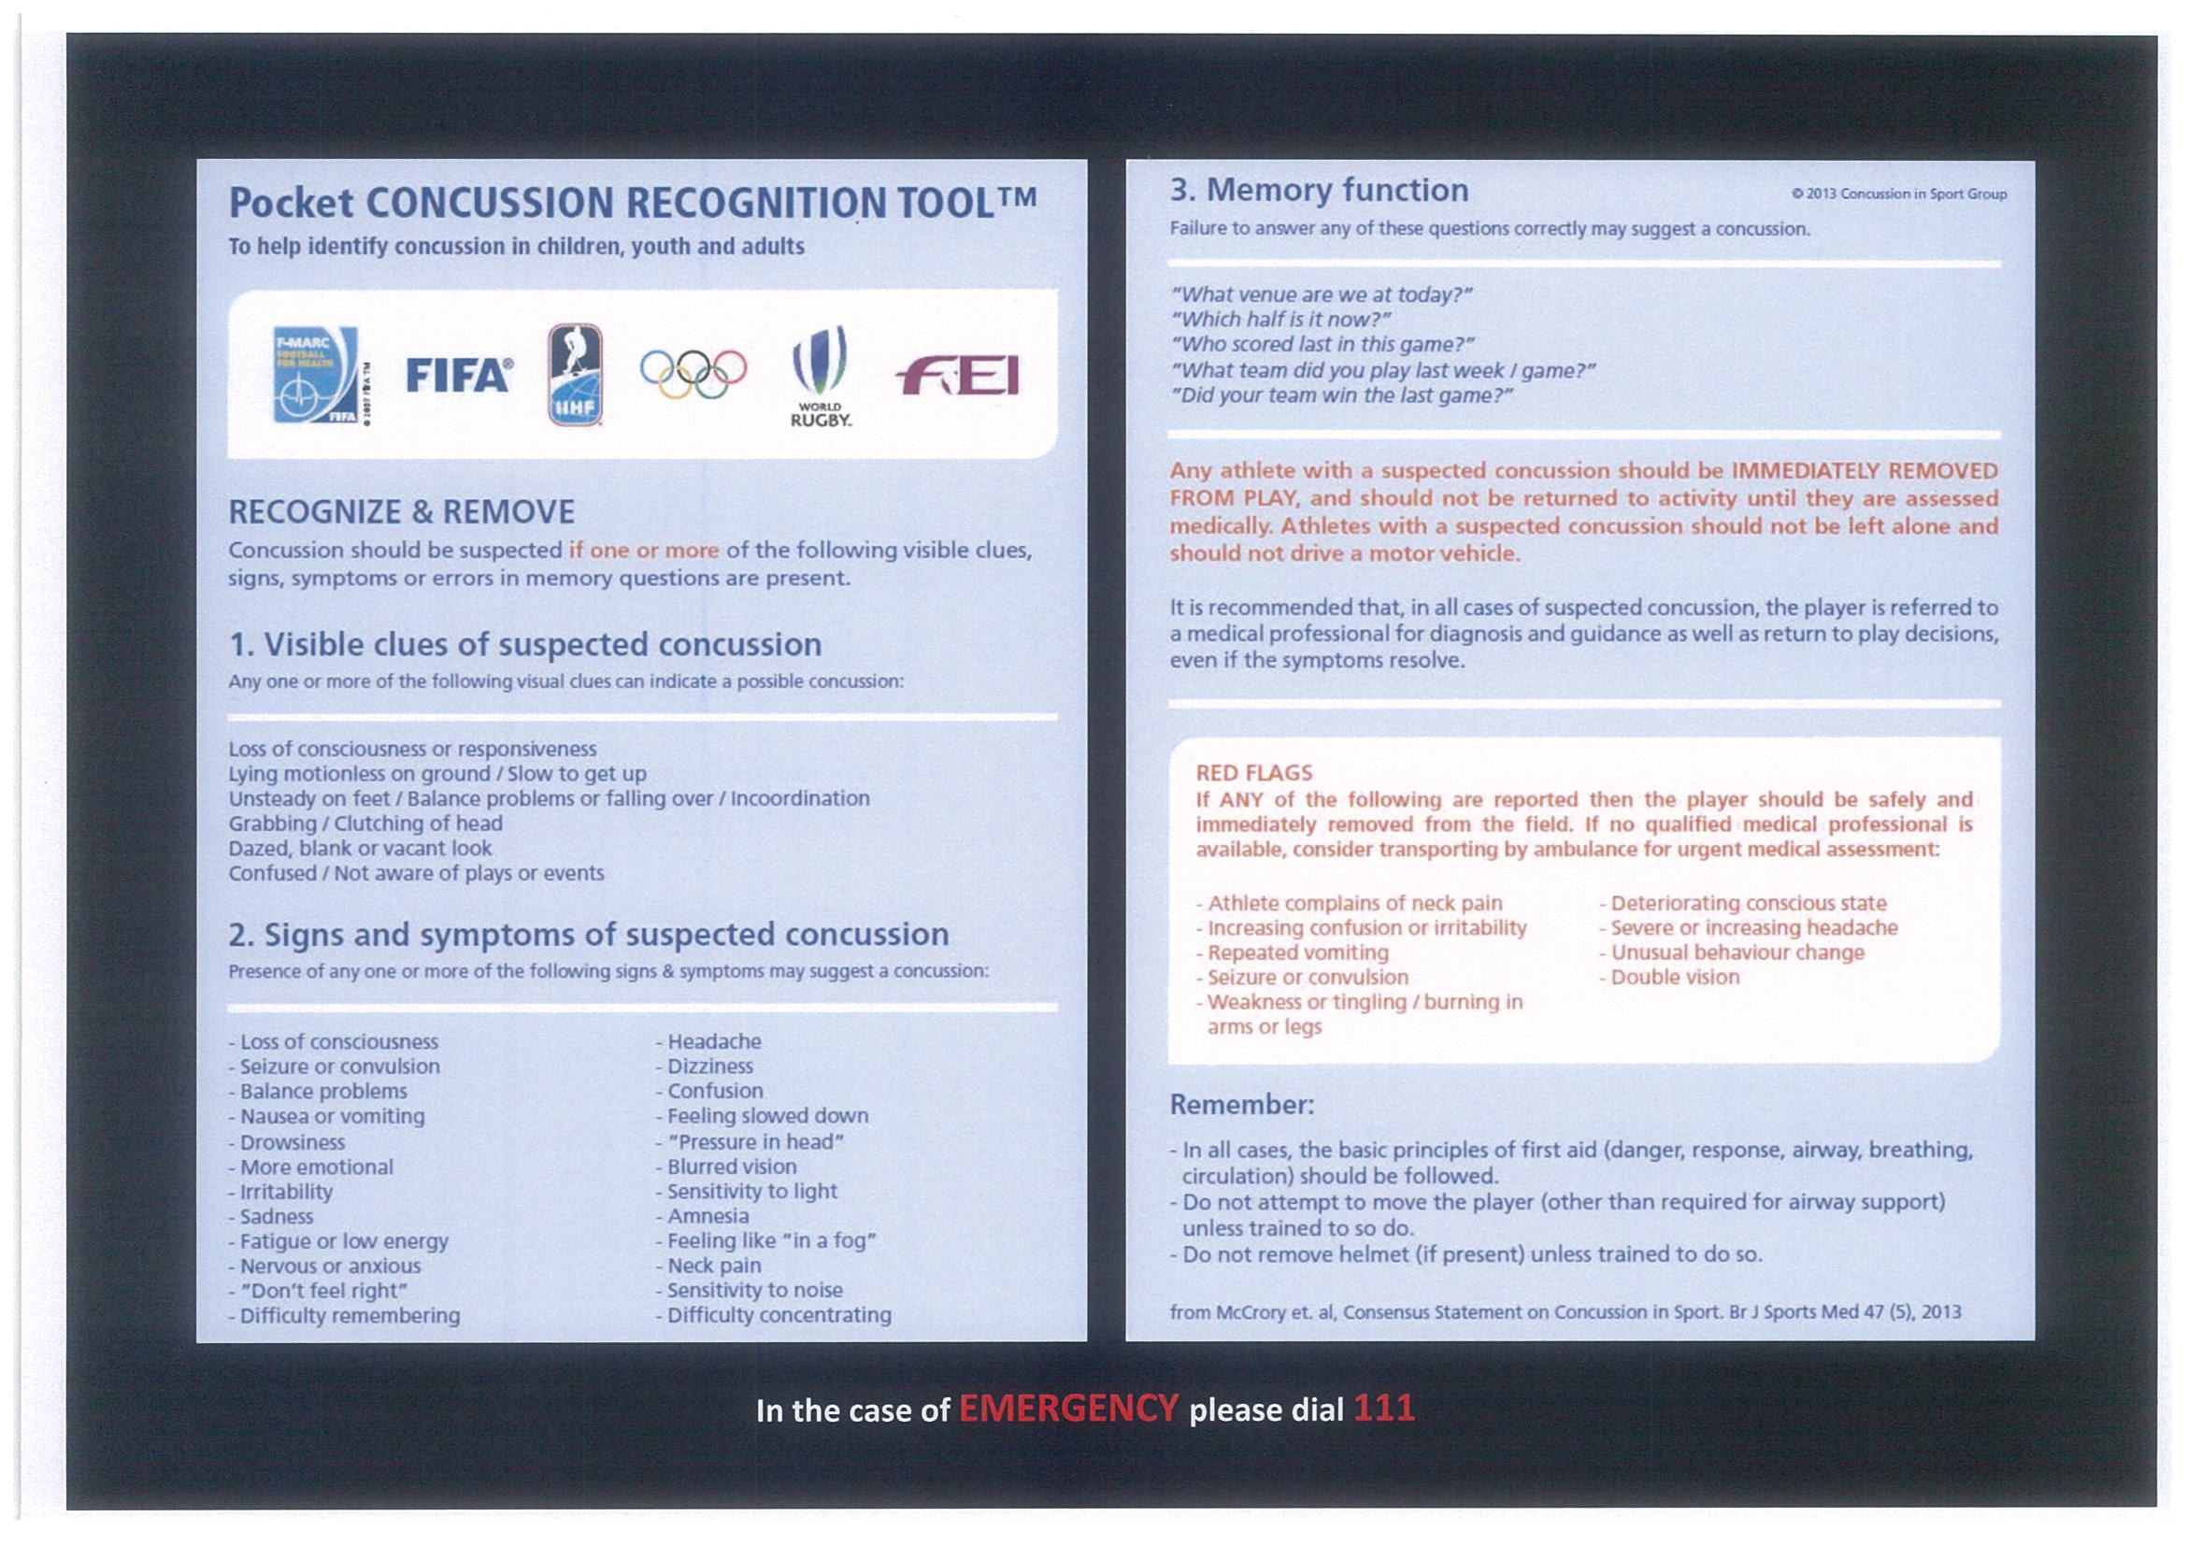

Appendix 5 - Code of Conduct
NZC Game On Code of Conducts for players, and coaches.
- On and off field misbehaviour can result in a player being sent home.
- Any damage to accommodation or dressing rooms shall be at the cost of the player responsible.
- There is a strict NO alcohol and drugs policy for all NDCA Tournaments – this includes vaping.

Any complaints are to be made in writing to NDCA Competition and Tournament Manager, via email to competitions@ndca.co.nz
