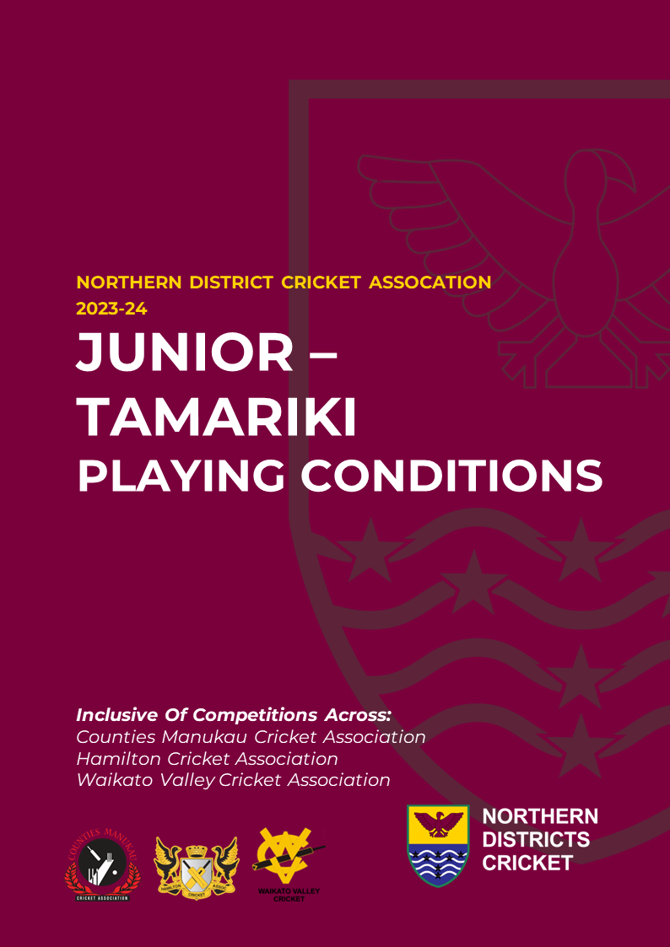

JUNIOR – TAMARIKI PLAYING CONDITIONS
The purpose of this document is to outline the playing conditions by which tamariki competitions will be operated.
This document will form the foundation for competitions operation, which will be led by competition administration on behalf of the District Association Boards.
CONTENTS
JUNIOR – TAMARIKI PHILOSOPHY OF PLAY 2
THANK YOU TO ALL GAME VOLUNTEERS 2
PLAYHQ SCORING PLATFORM 2
JUNIOR – TAMARIKI CANCELLATION POLICY 3
JUNIOR – TAMARIKI ANZ PLAYER CERTIFICATES 3
JUNIOR – TAMARIKI COACH INFORMATION 1
HELMET REGULATION 5
SAFEGUARDING 5
CONTACT US – COMPETITION ADMINISTRATION 5
NEW ZEALAND CRICKET CODE OF CONDUCTS 6
TAMARIKI BEHAVIOUR GUIDELINES 7
PLAYING CONDITIONS; JUNIOR - TAMARIKI 8
YEAR 3 - 4 SOFTBALL - TAMARIKI 8
YEAR 5 - 8 SOFTBALL - TAMARIKI 9
YEAR 5 - 6 HARDBALL - TAMARIKI 10
YEAR 7 - 8 HARDBALL 20 OVER - TAMARIKI 11
YEAR 7 - 8 HARDBALL 25 OVER - TAMARIKI 12
YEAR 7-8 HARDBALL 30 OVER – TAMARIKI 13

JUNIOR – TAMARIKI PHILOSOPHY OF PLAY
New Zealand Cricket, Northern Districts and District Associations welcome all participants to the tamariki game. With the purpose to “Connect People, Create Memories”, all abilities are provided for with a goal to ensure opportunities of play for all.
Across Northern Districts, all junior competition formats are aligned with the NZC Junior Game framework and the Sport NZ Balance is Better principles. This means a number of great considerations to focus on fun and enjoyment for our tamariki:
- Shorter Pitch lengths to reflect the proportionate size of pitch to player.
- Smaller team numbers to ensure more action, more movement, and more inclusion for each player.
- Shortened boundaries to bring to life boundary scoring and outfield catching.
- Batting connects; both pairs cricket and/or ‘grace periods’ have been implemented to encourage fair opportunities of play and for batters to play with courage and freedom.
- Encourage friends to continue to play with friends regardless of ability through the removal of grading leagues and selected teams across the Tamariki age groups.
Cricket’s objective is for every individual to love the game, connect, contribute and reach their potential, whether that be their local patch of grass or representing the Fern.

THANK YOU TO ALL GAME VOLUNTEERS
Tamariki play is founded from the passion, selflessness and connection of volunteers to the game and to our tamariki. From all across Northern Districts and the District Associations, we would like to acknowledge the significant contribution that all volunteers make to the game. As the heartbeat of the community game and the role models for our tamariki, thank you for enabling cricket to reach into the lives of tamariki and for the fun and enjoyment that you will share both on the field of play, at the beach and in the backyard. Cricket’s goal nationally is to be “A Game for All, A Game for Life” and our volunteers are the driving force behind every experience and memory of the game.

PLAYHQ SCORING PLATFORM
New Zealand Cricket have nominated the national competition and scoring platform as PlayHQ. All competitions across New Zealand are required to use this platform and to assist with learning and understanding the platform, Northern Districts has information online at Northern Districts PlayHQ.

JUNIOR – TAMARIKI CANCELLATION POLICY
The regional Competition Administration team are focused to ensure fixtures and opportunities of play are maximised throughout the season with a goal to ensure great game experiences for parents and tamariki.
With weather a critical factor to enabling play, the Competition Administration team acknowledge the importance to all families for timely notice to any cancellations, while ensuring the appropriate decision is made to maximise opportunity of play.
With competition administrations based across the region, individual decisions will be made based on each geographic area. Where play is possible, play will be encouraged, even if this means that some games proceed while others are unable (if for example there are scattered showers).
The following cancellation processes will occur with relevant contact details provided to each team to enable communications:
Region | Day of Play | Process of Cancellation
Counties Manukau | Any day of play | Cancelled by agreement between teams.
Hamilton | Midweek | Cancelled by agreement between teams.
Hamilton | Friday | Cancelled by 2:30pm each Friday as determined by Competition Administrator. Any cancellation decision will be communicated by Competition Administration to all team coaches and posted on the HCA Facebook page.
Hamilton | Saturday | Cancelled by 08:00am each Saturday as determined by Competition Administrator. Any cancellation decision will be communicated by Competition Administration to all team coaches and posted on the HCA Facebook page.
Waikato Valley | Any day of play | Cancelled by agreement between teams.

JUNIOR – TAMARIKI ANZ PLAYER CERTIFICATES
NZC is proud to partner with ANZ to provide each tamariki team across the country with certificates to celebrate “Most Valued Player” for each game of the season. Please contact your local regional Development Manager or Officer to receive your team allocation of certificates for the season.

JUNIOR – TAMARIKI COACH INFORMATION
All coaches must be registered via NZC’s online coaching database, Friendly Manager.
- New Coaches can register to become a coach here; New Coach Registration
- Existing Coaches can reregister to become a coach here: Existing Coach Registration
Safeguarding across the national game is a primary focus and as part of this process, all coaches must receive a clear police vet via the NZC police vet system and complete the Vulnerable Persons Modules available online upon registration. The safety and wellbeing of our tamariki and rangatahi participants is the games number one priority. All coaches are also encouraged to complete the relevant coach qualification which includes a practical session with a regional lead trained to develop and support coaches.
Coaches are, in so many ways, the sport. Coaches are the people children listen to, learn from and respect. Just as a great coach can inspire the hearts and minds of children to want to train and compete in sport, a poor coach can cause young participants and families to walk away from the game and potentially never to return. A network of appropriately qualified coaches which have completed appropriate coaching qualifications will assist to create a safe environment and improve coach capability to inspire the hearts and minds of children and young people, thereby retaining tamariki within the game.
At the heart of the new Coaching and Vulnerable Persons policy is the need to maintain a healthy, safe and enjoyable environment for all those who play cricket. Children enjoy their experience most when they are in a safe environment, learn and improve, play with friends and whanau and are given opportunities to contribute.
Adults interacting with children and/or vulnerable adults are in a position of trust and influence and, as such, have a significant role to play in creating this safe environment. As a part of NZC’s overall push for “best practice” standards in the area of coaching and supervision, the Vulnerable Persons policy and coach qualification is viewed as a fundamental requirement.
In terms of the police vetting process, NZC wishes to emphasise this is not an attempt to identify or disqualify individuals with minor or irrelevant criminal records, either current or historic. On the contrary, the initiative is based on creating safer and more secure cricketing environments for both children and vulnerable adults, and for those charged with upholding a duty of care and responsibility – i.e.: NZC, MAs, DAs and clubs.
ND and all District Associations would like to take this opportunity to thank coaches for all that you do and the valuable impact you have on our young tamariki.


HELMET REGULATION
Helmets are mandatory for all batters and wicket keepers in hard ball grades. Please refer to the NZC Helmet Policy for further information.

SAFEGUARDING
Northern Districts has outlined regional safeguarding: Northern Districts Safeguarding
Safeguarding is based upon the concept of providing an enjoyable environment tailored to the needs and requirements of Children and Vulnerable Adults. Adults interacting with children and vulnerable adults in sport are in a position of trust and influence and should therefore ensure that everyone is treated with integrity and respect while ensuring that the self-esteem of the person is enhanced. Everyone involved in delivering cricket, especially to children and vulnerable adults has a role to play in creating the best possible environment for all to participate within. Coaches and anyone engaging with tamariki and rangatahi must be police vetted.
Every person in cricket, in every role and no matter what age or stage has the right to participate in an environment that is fun, safe and healthy, and to be treated with respect, dignity and fairness.
Bullying denies participants these rights and can result in feelings of disgrace, embarrassment, shame or intimidation. Bullying can also affect an individual’s athletic performance, level of enjoyment, work or school life, academic achievement and physical and/or mental health.
Bullying can occur both on and off the field of play and can involve players, patents, coaches, spectators or umpires.
Northern Districts and District Associations do not accept bullying within the sport and sees it as everyone’s responsibility to implement and support anti-bullying within cricket and across all facets of life. New Zealand Cricket has developed the following Codes of Conduct for parents/caregivers, players and coaches to help ensure cricket is a safe and healthy environment for participants to engage within and enjoy.

CONTACT US – COMPETITION ADMINISTRATION
A number of dedicated competition administrators are active throughout the region and available to support with competition queries via the following avenues:
- Counites Manukau: admin@countiesmanukaucricket.co.nz and 021 253 9316
- Waikato: competitions@ndca.co.nz and 027 222 7893
Please note that it is the responsibility of playing teams to resolve on-field issues.
NEW ZEALAND CRICKET CODE OF CONDUCTS

NZC GAME ON; PLAYERS, COACHES AND PARENT/ CAREGIVERS

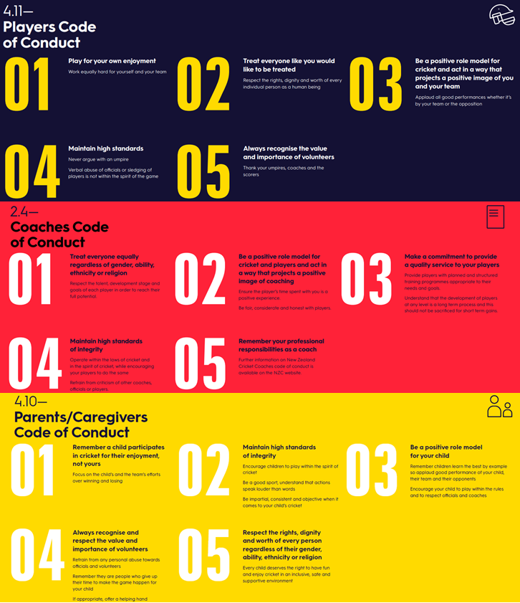

TAMARIKI BEHAVIOUR GUIDELINES
All players, umpires, managers, coaches, parents and spectators should play cricket with the following ideas in mind:

Player | Coaches/Managers/Parents
Play by the rules and respect all decisions made by umpires | Be a positive role module. Players and tamariki learn from the examples they see
Be humble in winning and gracious in losing | Focus on development, not the result. Create an environment with is fun to learn and play in.
Enjoy playing with your team, and cooperate with coaches/parents/officials | Respect the decisions of those around you
Do your best to listen and learn from your coach | Encourage everyone, celebrate success no matter how small.
Thank your opposition, officials, coaches and team after every game | Set the standard of “positive vibes” on the sideline. Poor behaviour will not be tolerated
Play to your best ability, giving 100% effort but remember winning is not everything | Remember tamariki are participating for their enjoyment of the game, not yours

Tamariki Behavioural Process
Where possible coaches/managers should make reasonable attempts to diffuse and resolve any behavioural issues in teams.
Failing this, any player, coach, manager or spectator can lodge a complaint to competitions@ndca.co.nz via email within 3 days of the event. Those sighted within the compliant will have an opportunity to respond to the complaint.

The CA will decide on the complaint and will consider all views of the compliant. At stages, the CA may chose to approach other parties to establish further information.

The CA will use the below table for relevant sanctions following any individual or team complaints.
First Strike | The club/team/individual will receive a written warning of consequences of further “strikes” in regard to tamariki behaviour
Second Strike | The club/team/individual may be required to engage in educational practices. This may be led by NDCA or an external resource.
Third Strike | This may result in suspension from participation within competitions for a period of time.

PLAYING CONDITIONS; JUNIOR - TAMARIKI

YEAR 3 - 4 SOFTBALL - TAMARIKI
SET UP A GAME
Hours of play | Friday Night - 5.30pm start time, Saturday Morning – 8.45am start time.  GAME DURATION: 75 MINUTES
Team | 8 players per team (Waikato), 8-10 players (Counties Manukau)
Overs per team | 12 overs: An over shall consist of 6 balls bowled including all extras, eg. wides and no-balls.
Pitch Length | 14 meters
Boundaries | Maximum of 30 meters from the centre of the pitch.
Equipment | - Spring-loaded or plastic stumps.  - Pliable plastic/soft ball or similar.  - Plastic or wooden bats  - Any clothing, preferred team clothing to be school or club uniforms.
GAME IN PLAY
Batting | Players will bat in pairs. Each batting pair will bat for 3 overs.  - All Players should have an ‘even-share’ to face the bowler/ strike the ball.  - Any wickets taken will increase the bowling teams’ score by +3 runs and the batters must change ends.  - Individual batting scores are added together for the partnership score.  - Batters can be dismissed: Bowled, Caught or Run Out. There are no LBW’s or Stumpings
Bowling | All bowling is to take place from one end only.  - Run ups for bowlers should not exceed more than 10 meters.  - All players must bowl minimum 1 over or a maximum of 2, including the wicket-keeper  Bowling Extras:  - Any wides or ‘no-balls’ shall be counted as +2 runs each (which are to be added to the batting team’s total).  - No-Balls: a ball over waist height on the full.  - Wide: if the batter cannot reach the ball while in their stance. A wide cannot be called if the batter makes any contact with the ball.
Fielding | - No fielder is allowed to stand within ten meters of the batter.  - Fielders including the wicket-keeper should rotate clockwise at the end of each over to experience different fielding positions.  - No more than three fielders are permitted on the leg-side.

YEAR 5 - 8 SOFTBALL - TAMARIKI
SET UP A GAME
Hours of play | 5.30pm start time  GAME DURATION: 90 MINUTES
Team | 8 players per team
Overs per team | 16 overs: An over shall consist of 6 balls bowled, with a maximum of 8 deliveries if extras (wides and no-balls) are bowled.
Pitch Length | 14 meters or as agreed appropriate for the players (maximum of 18 meters)
Boundaries | Maximum of 35 meters from the centre of the pitch.
Equipment | - Spring-loaded or plastic stumps  - Pliable plastic/soft ball or similar.  - Plastic or wooden bats  - Any clothing, preferred team clothing to be school or club uniforms.
GAME IN PLAY
Batting | Players will bat in pairs. Each batting pair will bat for 4 overs.  - All Players should have an ‘even-share’ to face the bowler/ strike the ball.  - Any wickets taken will increase the bowling teams’ score by +3 runs and the batters must change ends.  - Individual batting scores are added together for the partnership score.  - Batters can be dismissed: Bowled, Caught, Run Out or Stumped. There are no LBW’s
Bowling | All bowling is to take place from one end only.  - Run ups for bowlers should not exceed more than 10 meters.  - All players must bowl 2 overs, including the wicket-keeper  Bowling Extras:  - Any wides or ‘no-balls’ shall be counted as +2 runs each (which are to be added to the batting team’s total).  - No-Balls: a ball over waist height on the full.  - Wide: if the batter cannot reach the ball while in their stance. A wide cannot be called if the batter makes any contact with the ball.
Fielding | - No fielder is allowed to stand within ten meters of the batter.  - Fielders including the wicket-keeper should rotate clockwise at the end of each over to experience different fielding positions.  - No more than three fielders are permitted on the leg-side.

YEAR 5 - 6 HARDBALL - TAMARIKI
SET UP A GAME
Hours of play | 8.45am or 9am start time, as per draw  GAME DURATION: 2 HOURS 30 MINUTES
Team | 8 players per team
Overs per team | 20 overs: An over shall consist of 6 balls bowled, with a maximum of 8 deliveries if extras (wides and no-balls) are bowled.
Pitch Length | 16 meters
Boundaries | Maximum of 35 meters from the centre of the pitch.
Equipment | Protective gear is required:  - Shoes must be worn.  - Batters must wear batting pads, batting gloves, abdomen guard(box), and helmets.  - All wicket-keepers must wear gloves and a helmet.  - Spring-loaded stumps  - 142-gram Kookaburra two-piece leather ball must be used.  - Wooden bats  - Any clothing, preferred team clothing to be school or club uniforms.
GAME IN PLAY
Batting | Players will bat in pairs. Each batting pair will bat for 5 overs.  - All Players should have an even share of the strike.  - Any wickets taken will increase the bowling teams’ score by +3 runs and the batters must change ends.  - Individual batting scores are added together for the partnership score.  - Batters can be dismissed: Bowled, Caught, Run Out or Stumped. There are no LBW’s
Bowling | All bowling is to take place from one end only.  - Run ups for bowlers should not exceed more than 10 meters.  - All players must bowl 2 overs, including the wicket-keeper, before any bowler can bowl their third over. No bowler shall bowl more than 3 overs.  Bowling Extras:  - Wide – if the batter cannot reach the ball while playing a normal cricket shot. A wide cannot be called if the batter makes any contact with the ball.  - Wides shall be counted as 1 run which is to be added to the batting team’s total.  - No-Balls – a ball over waist height on the full.  - For no-balls 1 run is added to the score under extras, and any resulting runs off the bar are credited as runs to the batter
Fielding | - No fielder is allowed to stand within ten meters of the batter except for the wicket-keeper and off side slips.  - No more than 3 fielders are permitted on the leg-side.
Rain Rule | Play will not commence in rain. If time is lost due to the weather, coaches should agree on reducing the total overs by 2 overs for every 6 minutes lost so that lost time is allocated as equally as possible.  Player welfare must come first.
Scoring | - Results are to be submitted via PlayHQ. The team named first on the draw is responsible to do so.

YEAR 7 - 8 HARDBALL 20 OVER - TAMARIKI
SET UP A GAME
Hours of play | 8.45am or 9am start time, as per draw  GAME DURATION: 2 HOURS 30 MINUTES
Team | 9 players per team. If a team is composed of 10 players, a nominated non-batter must be provided.
Overs per team | 20 overs: An over shall consist of 6 balls bowled, with a maximum of 8 deliveries if extras (wides and no-balls) are bowled.
Pitch Length | 18 meters
Boundaries | Maximum of 40 meters from the centre of the pitch.
Equipment | Protective gear is required:  - Shoes must be worn.  - Batters must wear batting pads, batting gloves, abdomen guard(box), and helmets.  - All wicket-keepers must wear gloves and a helmet.  - Spring-loaded stumps  - New 142-gram Kookaburra two-piece leather ball must be used.  - Wooden bats  - Any clothing, preferred team clothing to be school or club uniforms.
GAME IN PLAY
Batting | - LBW’s only apply if the batter is struck below the knee roll or is hit behind the batting crease.  - Batters must face a minimum of 6 balls (Grace period) after 6 balls all dismissals apply. Any dismissals in the grace period will award the bowling team with 4 runs. If a batter gets out, batters must change ends.  - Batters must retire after facing 25 deliveries (wides and no-balls included). Retired batters providing they didn’t get out in the first 6 balls, can resume their innings, in the order they retired, once all other players have been dismissed or retired.
Bowling | - The bowling will take place for 5 over blocks from one end and then swap for the next 5 overs at the other end.  - Run ups for bowlers should not exceed more than 15 meters.  - No bowler shall bowl more than 5 overs in an innings or more than one-sixth of the total overs in a rain-shortened inning.  Bowling Extras:  - Wide – A ball deemed to have passed more than 200mm outside the leg stump will be called a wide. Off-side wides will be called if the batter cannot reasonably reach the ball while playing a normal cricket shot. A wide cannot be called if the batter makes any contact with the ball.  - Wides shall be counted as 1 run to be added to the batting team’s total.  - No-Balls – a ball over waist height on the full or if a ball bounces more than once.  - For no-balls 1 run is added to the score under extras, and any resulting runs off the bar are credited as runs to the batter
Fielding | - No fielder is allowed to stand within ten meters of the batter except for the wicket-keeper and off side slips.  - No more than 4 fielders are permitted on the leg-side and no more than 4 outside the 20-meter assumed circle at any time, and no more than 2 behind square on the leg side.
Rain Rule | Play will not commence in rain. If time is lost due to the weather, coaches should agree on reducing the total overs by 2 overs for every 6 minutes lost so that lost time is allocated as equally as possible. Player welfare must come first.
Scoring | - Results are to be submitted via PlayHQ. The team named first on the draw is responsible to do so.

YEAR 7 - 8 HARDBALL 25 OVER - TAMARIKI
SET UP A GAME
Hours of play | 8.45am or 9am start time, as per draw  GAME DURATION: 3 HOURS
Team | 9 players per team. If a team is composed of 10 players, a nominated non-batter must be provided
Overs per team | 25 overs: An over shall consist of 6 balls bowled, with a maximum of 8 deliveries if extras (wides and no-balls) are bowled.
Pitch Length | 18 meters
Boundaries | Maximum of 40 meters from the centre of the pitch.
Equipment | Protective gear is required:  - Shoes must be worn.  - Batters must wear batting pads, batting gloves, abdomen guard(box), and helmets.  - All wicket-keepers must wear gloves and a helmet.  - Spring-loaded stumps  - New 142-gram Kookaburra two-piece leather ball must be used.  - Wooden bats  - Any clothing, preferred team clothing to be school or club uniforms.
GAME IN PLAY
Batting | - LBW’s only apply if the batter is struck below the knee roll or is hit behind the batting crease.  - Batters must face a minimum of 6 balls (Grace period) after 6 balls all dismissals apply. Any dismissals in the grace period will award the bowling team with 4 runs. If a batter gets out, batters must change ends.  - Batters must retire after facing 30 deliveries (wides and no-balls included). Retired batters providing they didn’t get out in the first 6 balls, can resume their innings, in the order they retired, once all other players have been dismissed or retired.
Bowling | - The bowling will take place for 5 over blocks from one end and then swap for the next 5 overs at the other end.  - Run ups for bowlers should not exceed more than 15 meters.  - No bowler shall bowl more than 4 overs in an innings or more than one-sixth of the total overs in a rain-shortened inning.  Bowling Extras:  - Wide – A ball deemed to have passed more than 200mm outside the leg stump will be called a wide. Off-side wides will be called if the batter cannot reasonably reach the ball while playing a normal cricket shot. A wide cannot be called if the batter makes any contact with the ball.  - Wides shall be counted as 1 run to be added to the batting team’s total.  - No-Balls – a ball over waist height on the full or if a ball bounces more than once.  - For no-balls a 1 run is added to the score under extras, and any resulting runs off the bar are credited as runs to the batter
Fielding | - No fielder is allowed to stand within ten meters of the batter except for the wicket-keeper and off side slips.  - No more than 4 fielders are permitted on the leg-side and no more than 4 outside the 20-meter assumed circle at any time, and no more than 2 behind square on the leg side.
Rain Rule | Play will not commence in rain. If time is lost due to the weather, coaches should agree on reducing the total overs by 2 overs for every 6 minutes lost so that lost time is allocated as equally as possible. Player welfare must come first.
Scoring | - Results are to be submitted via PlayHQ. The team named first on the draw is responsible to do so.

YEAR 7-8 HARDBALL 30 OVER – TAMARIKI
SET UP A GAME
Hours of play | 8.45am or 9am start time, as per draw  GAME DURATION: 3 HOURS 30 MINUTES
Team | 9 players per team. If a team is composed of 10 players, a nominated non-batter must be provided
Overs per team | 30 overs: An over shall consist of 6 balls bowled, with a maximum of 8 deliveries if extras (wides and no-balls) are bowled.
Pitch Length | 18 meters
Boundaries | Maximum of 40 meters from the centre of the pitch.
Equipment | Protective gear is required:  - Shoes must be worn.  - Batters must wear batting pads, batting gloves, abdomen guard(box), and helmets.  - All wicket-keepers must wear gloves and a helmet.  - Spring-loaded stumps  - New 142-gram Kookaburra two-piece leather ball must be used.  - Wooden bats  - Any clothing, preferred team clothing to be school or club uniforms.
GAME IN PLAY
Batting | - LBW’s only apply if the batter is struck below the knee roll or is hit behind the batting crease. All judgment regarding height must be through consultation with the square-leg umpire.  - Batters must face a minimum of 6 balls (Grace period) after 6 balls all dismissals apply. Any dismissals in the grace period will award the bowling team with 4 runs. If a batter gets out, batters must change ends.  - Batters must retire after facing 30 deliveries (wides and no-balls included). Retired batters providing they didn’t get out in the first 6 balls, can resume their innings, in the order they retired, once all other players have been dismissed or retired.
Bowling | - The bowling will take place for 5 over blocks from one end and then swap for the next 5 overs at the other end.  - Run ups for bowlers should not exceed more than 15 meters.  - No bowler shall bowl more than 5 overs in an innings or more than one-sixth of the total overs in a rain-shortened inning.  Bowling Extras:  - Wide – A ball deemed to have passed more than 200mm outside the leg stump will be called a wide. Off-side wides will be called if the batter cannot reasonably reach the ball while playing a normal cricket shot. A wide cannot be called if the batter makes any contact with the ball.  - Wides shall be counted as 1 run to be added to the batting team’s total.  - No-Balls – a ball over waist height on the full or if a ball bounces more than once.  - For no-balls a 1 run is added to the score under extras, and any resulting runs off the bar are credited as runs to the batter
Fielding | - No fielder is allowed to stand within ten meters of the batter except for the wicket-keeper and off side slips.  - No more than 4 fielders are permitted on the leg-side and no more than 4 outside the 20-meter assumed circle at any time, and no more than 2 behind square on the leg side.
Rain Rule | Play will not commence in rain. If time is lost due to the weather, coaches should agree on reducing the total overs by 2 overs for every 6 minutes lost so that lost time is allocated as equally as possible. Player welfare must come first.
Scoring | - Results are to be submitted via PlayHQ. The team named first on the draw is responsible to do so.

